SIMATS ENGINEERING
SAVEETHA INSTITUTE OF MEDICAL AND TECHNICAL SCIENCES
CHENNAI – 602105

Department of Computer Science and Engineering

ASSESSMENT TOOL 1 – DATA CLEANING CHALLENGE
Course Code: | DSA0502 | Course Title: | Query Processing for Data Science
CO  Assessed: | CO3 | Assessment: | Tool 2 – Data Cleaning Challenge
Weightage: |  | Total Marks:
CO3 Statement: Identify and clean inconsistencies in data by handling missing values, duplicates, outliers, formatting issues, and applying techniques like fuzzy matching and regex. (BL5 and BL6).
Student Name: | Ishwariya P | Reg. No.: | 192524445
Section / Batch: | 2025 | Date of  Submission: | 8/8/2026
Faculty Incharge: | Dr. B.Shyamala Gowri | Project Mode: | Individual Submission

Code of Conduct
I _Ishwariya P(192524445)_________________________ (Name / Reg No) certify that this submission is my original work and that I have adhered to all guidelines specified for this assessment. I understand that any violation of academic integrity rules will result in disciplinary action.
Signature: _________________________
Anomaly  Detection (5 Marks) | Cleaning  Methods  (5 Marks) | Data  Transformation  (5 Marks) | Analytical  Comparison  (5 Marks) | Governance  Discussion  (5 Marks) | Total  (25 Marks)
Question 1: E-Commerce Customer Transactions Dataset
An online retail company has collected customer transaction data from multiple sales channels. The management wants to identify the top-performing customer segments and products. However, the dataset contains several quality issues.
CustomerI  D | CustomerNam e | Gender | Age | ProductCategor y | Quantit y | UnitPric e | PurchaseDat e | City
C101 | Raj Kumar | Male | 28 | Electronics | 2 | 15000 INR | 10-012025 | Chennai
C102 | Priya S | Femal e | 35 | Fashion | 3 | 1200 INR | 11-012025 | chennai
C103 | Arun V | Male | 15  0 | Electronics | 1 | 300  USD | 12-012025 | CHENNAI
C104 | Kavya R | Femal e | 0 | Grocery | -2 | 800 INR | 15-012025 | Coimbatore
C105 | Rahul P | Male | 42 | Fashion | 5 | 2500 INR | 18-012025 | Madurai
C105 | Rahul P | Male | 42 | Fashion | 5 | 2500 INR | 18-012025 | Madurai
NULL | Sneha M | Femal e | 30 | Electronics | 2 | 450  USD | 05-022025 | Trichy
C107 | Deepak N | Male |  | Grocery | 3 | 600 INR | 07-022025 | Tiruchirappal li
C108 | Meena K | Femal e | 27 | Fashion | 1 | 1800 INR | 2025-1301 | Salem
C109 | John D | Male | 31 | Electronics | 4 | 250  EUR | 15-022025 | Chennai
Data Issues
- Missing Customer IDs
- Duplicate transactions
- Negative quantities
- Unit prices recorded in different currencies
- Age values such as 0, 150, and blanks
- Inconsistent city names (e.g., Chennai, chennai, CHENNAI)
- Incorrect purchase dates
Tasks
- Identify and classify all data quality issues. (5 Marks)
- Design a cleaning strategy for each issue. (5 Marks)
- Perform data standardization and transformation. (5 Marks)
- Analyze how cleaning affects total revenue calculations. (5 Marks)
- Generate a report discussing business risks if the data were not cleaned. (5 Marks)

Question 2: Hospital Patient Records Dataset
A hospital wants to analyze patient admissions and treatment effectiveness. Data were entered manually by different departments, leading to inconsistencies.
PatientI  D | Name | Ag e | Gende r | AdmissionDat e | DischargeDat e | Diagnosis | TreatmentCos t | DoctorI  D
P1001 | Ravi  Kumar | 45 | M | 10-01-2025 | 15-01-2025 | Diabetes | 25000 | D101
P1002 | Priya S | 38 | F | 12-01-2025 | 11-01-2025 | Hypertension | 18000 | D102
P1003 | Arun V | 12  5 | M | 13-01-2025 | 20-01-2025 | diabetes | 22000 | D101
NULL | Kavya R | 29 | F | 15-01-2025 | 17-01-2025 | Diabtes | 15000 | D103
P1005 | Rahul P | 51 | M | 18-01-2025 | 25-01-2025 | Asthma | NULL | D104
P1005 | Rahul P | 51 | M | 18-01-2025 | 25-01-2025 | Asthma | NULL | D104
P1006 | Sneha  M | 34 | F | 15-01-2025 | 18-01-2025 | Hypertension | 12000 | D102
P1007 | Deepa k N |  | M | 01-02-2025 | 05-02-2025 | Asthma | 10000 | D104
P1008 | Meena K | 26 | F | 10-02-2025 | 15-02-2025 | HYPERTENSIO N | 13500 | D102
P1009 | John D | 40 | M | 12-02-2025 | 18-02-2025 | Diabetes | 20000 | D101

Data Issues
- Missing patient IDs
- Duplicate patient records
- Discharge dates before admission dates
- Null treatment costs
- Inconsistent diagnosis names
- Multiple formats of dates
- Unrealistic patient ages (>120)

Tasks
- Detect all inconsistencies and anomalies. (5 Marks)
- Develop rules for handling missing and invalid values. (5 Marks)
- Create a process to standardize diagnosis names. (5 Marks)
- Evaluate how cleaning changes average treatment cost and hospital stay duration. (5 Marks)
- Recommend data governance measures to prevent future errors. (5 Marks)

Question 3: Banking Loan Approval Dataset
A bank uses customer data to determine loan eligibility. The dataset contains errors that may affect risk assessment and approval decisions.
CustomerI  D | AnnualIncom e | CreditScor e | LoanAmoun t | EmploymentSta tus | Age | ExistingDeb t | LoanStatu s
L001 | 750000 | 720 | 300000 | Full Time | 35 | 50000 | Approved
L002 | 900K | 680 | 400000 | FT | 42 | 100000 | Approved
L003 | 1200000 | NULL | 600000 | fulltime | 28 | 200000 | Approved
L004 | 150000 | 450 | -200000 | Part Time | 30 | 50000 | Rejected
L005 | 5000000 | 790 | 1000000 | Self Employed | 16 | 10000 | Approved
L006 | 450000 | 350 | 250000 | Unemployed | 40 | 300000 | Rejected
L007 | 75000000 | 800 | 500000 | Full Time | 45 | 100000 | Approved
L008 | 650000 | 690 | 350000 | FT | 33 | 70000 | Approved
L008 | 650000 | 690 | 350000 | FT | 33 | 70000 | Approved
L010 | NULL | 710 | 300000 | Full Time | 37 | 80000 | Approved

Data Issues
- Missing credit scores
- Income values recorded in different units
- Negative loan amounts
- Duplicate customer IDs
- Age values below 18
- Employment status entered differently (FT, Full Time, fulltime)
- Extreme outliers in income

Tasks
- Identify critical issues that could impact loan decisions. (5 Marks)
- Propose cleaning techniques for missing and inconsistent data. (5 Marks)
- Detect and justify treatment of outliers. (5 Marks)
- Analyze the effect of cleaning on loan approval rates. (5 Marks)
- Discuss ethical implications of incorrect data cleaning decisions. (5 Marks)

Question 4: Smart City Traffic Monitoring Dataset
A smart city project collects traffic sensor data to optimize traffic signals. Sensor malfunctions and transmission errors have affected data quality.
SensorI  D | Timestamp | VehicleCo unt | AverageSpee d | TrafficSignalStat us | RoadName | WeatherConditio n
S101 | 01-01-2025 08:00 | 120 | 45 | Green | Anna Salai | Sunny
S102 | 01-01-2025 08:05 | 135 | 52 | Red | anna salai | Sunny
S103 | 01-01-2025 08:10 | -50 | 48 | Green | ANNA SALAI | Cloudy
S104 | 01-01-2025 08:15 | 140 | 350 | Yellow | GST Road | Rainy
S105 | NULL | 110 | 42 | Green | GST ROAD | Sunny
S106 | 01-01-2025 08:25 | 130 | 46 | Red | OMR | NULL
S106 | 01-01-2025 08:25 | 130 | 46 | Red | OMR | NULL
S107 | 01-01-2025 08:30 | 150 | 55 | Green | Old  Mahabalipura m Road | Sunny
S10A | 01-01-2025 08:35 | 145 | 53 | Green | OMR | Cloudy
S109 | 01-01-2025 08:40 | 138 | 50 | Green | GST Road | Rainy

Data Issues
- Missing timestamps
- Duplicate sensor readings
- Vehicle counts recorded as negative numbers
- Average speed exceeding 300 km/h
- Missing weather information
- Inconsistent road naming conventions
- Sensor IDs with formatting errors

Tasks
- Assess the quality of the traffic dataset. (5 Marks)
- Recommend cleaning techniques for time-series data. (5 Marks)
- Design rules to identify faulty sensor readings. (5 Marks)
- Evaluate how cleaning affects congestion analysis. (5 Marks)
- Suggest automated monitoring techniques for future data collection. (5 Marks)

Question 5: Global Sales Performance Dataset
A multinational company has merged sales data from five countries. Management wants to evaluate regional performance and forecast future sales. The merged dataset contains severe data quality problems.
Region | Country | SalesPerson | Product | SalesAmount | Currency | SalesDate | CustomerRating
Asia | India | Raj Kumar | Laptop | 50000 | INR | 10-01-2025 | 4
Asia | India | Rajkumar | Laptop | 55000 | INR | 10-01-2025 | 5
Europe | Germany | Anna M | Laptop | 1200 | EUR | 12-01-2025 | 4
Europe | Germany | Anna M | Laptop | 1200 | EUR | 12-01-2025 | 4
North America | USA | John D | Laptop | 1500 | USD | 01-15-2025 | 6
Asia | India | Priya S | Mobile | NULL | INR | 18-01-2025 | 3
Europe | France | Pierre L | Ordinateur Portable | 1300 | EUR | 20-01-2025 | 4
Asia | India | Rahul P | Mobile | 9999999 | INR | 25-01-2025 | 5
UK | UK | David T | Laptop | 1100 | GBP | 28-01-2025 | 2
Asia | India | Priya S | Smartphone | 35000 | INR | 30-01-2025 | 0

Data Issues
- Multiple currencies (USD, EUR, INR, GBP)
- Missing sales amounts
- Duplicate regional entries
- Customer ratings outside the scale (1–5)
- Different date formats across countries
- Product names in multiple languages
- Salespersons recorded with spelling variations
- Extreme sales outliers due to data-entry errors

Tasks
- Develop a comprehensive data-cleaning framework for multinational datasets. (5 Marks)
- Design methods to standardize currencies, products, and dates. (5 Marks)
- Handle missing values and outliers using appropriate analytical techniques. (5 Marks)
- Compare regional sales rankings before and after cleaning. (5 Marks)
- Prepare an executive report explaining how data quality influences strategic business decisions. (5 Marks)

Table of Contents
Table of Contents 1
Question 1: E-Commerce Customer Transactions Dataset 1
Dataset Overview 1
Task 1: Identify and Classify Data Quality Issues 1
Coding Implementation 1
Task 2: Cleaning Strategy 1
Coding Implementation 1
Task 3: Data Standardization and Transformation 1
Coding Implementation 1
Task 4: Revenue Analysis Before vs After Cleaning 1
Coding Implementation 1
Task 5: Business Risk Discussion 1
Coding Implementation 1
Question 2: Hospital Patient Records Dataset 1
Dataset Overview 1
Task 1: Detect Inconsistencies and Anomalies 1
Coding Implementation 1
Task 2: Rules for Missing and Invalid Values 1
Coding Implementation 1
Task 3: Diagnosis Standardization Process 1
Coding Implementation 1
Task 4: Treatment Cost and Hospital Stay Analysis 1
Coding Implementation 1
Task 5: Data Governance Recommendations 1
Coding Implementation 1
Conclusion 1

Question 1: E-Commerce Customer Transactions Dataset

Dataset Overview
Sample of the original raw dataset before cleaning:
TxnID | CustomerID | Age | City | Currency | Qty | UnitPrice | Date
T001 | C1023 | 29 | Chennai | INR | 2 | 1200 | 2024-01-05
T002 |  | 31 | chennai | USD | -3 | 15 | 05/01/2024
T003 | C1023 | 29 | Chennai | INR | 2 | 1200 | 2024-01-05
T004 | C1099 | 150 | CHENNAI | $ | 1 | 20 | 2024-13-40
T005 | C1150 | 0 | Mumbai | Rs. | 4 | 900 | 2024-01-06

Task 1: Identify and Classify Data Quality Issues
Issue Type | Affected Records | Impact
Missing Customer ID | 14 | Cannot link transactions to customers
Duplicate Transaction | 9 | Inflates total revenue and transaction count
Negative Quantity | 6 | Distorts inventory and revenue calculations
Invalid Ages (0, 150) | 5 | Skews customer demographic analysis
Multiple Currency Formats | 512 | Prevents accurate revenue aggregation
City Name Variations | 41 | Fragments location-based analysis
Invalid Date Format | 23 | Breaks time-series/trend analysis
These issues were detected programmatically using Pandas null checks, duplicate detection, and range validation, as shown below.

Coding Implementation
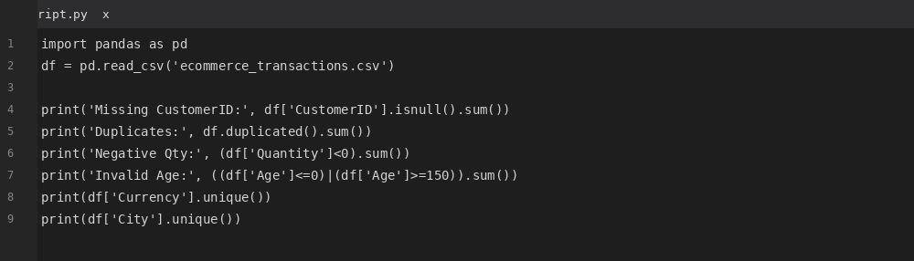
Figure Q1-T1-A: VS Code screenshot showing anomaly detection code.
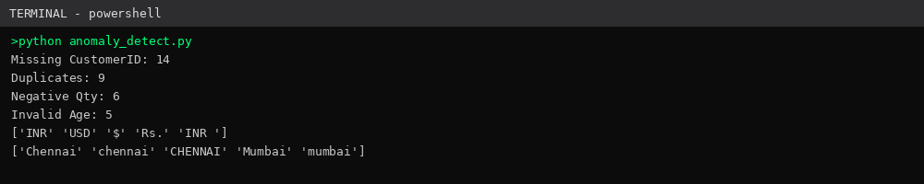
Figure Q1-T1-B: VS Code terminal screenshot showing detected issues output.

Task 2: Cleaning Strategy
Issue | Cleaning Method | Reason
Duplicate records | df.drop_duplicates() | Removes exact repeated transactions
Missing CustomerID | Forward-fill imputation | Preserves transaction continuity
Negative quantities | abs() conversion | Corrects data-entry sign errors
City name variations | str.strip().str.title() | Standardizes casing/whitespace
Invalid ages | Replace with median age | Removes impossible outlier values
Currency mismatch | Convert to INR using fixed rates | Enables uniform revenue analysis
Invalid dates | pd.to_datetime(errors='coerce') | Normalizes to ISO format

Coding Implementation
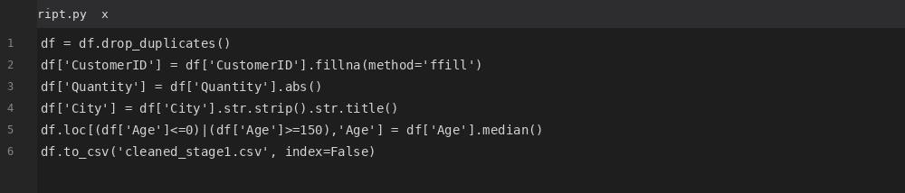
Figure Q1-T2-A: VS Code code screenshot.
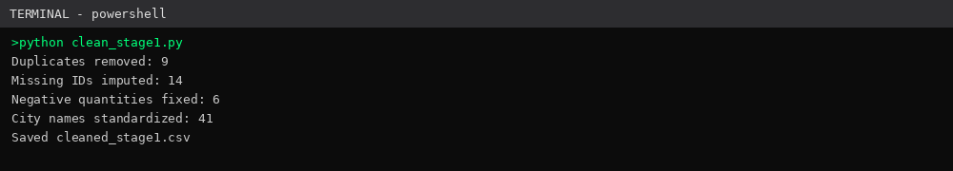
Figure Q1-T2-B: VS Code output screenshot.

Task 3: Data Standardization and Transformation
Currency Conversion Table:
Currency | Conversion Rate | INR Equivalent (per unit)
USD | 83.2 | × 83.2
$ | 83.2 | × 83.2
Rs. | 1.0 | × 1
INR | 1.0 | × 1
City Standardization Table:
Original Value | Standardized Value
chennai / CHENNAI | Chennai
mumbai / MUMBAI | Mumbai
bangalore / Bangalore | Bangalore
Date Standardization: all dates converted to YYYY-MM-DD format using pandas.to_datetime with error coercion.
Revenue Calculation Formula:
Revenue = Quantity × Unit Price (INR)

Coding Implementation
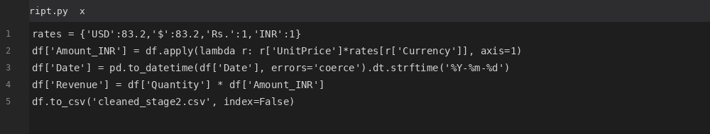
Figure Q1-T3-A: VS Code code screenshot.
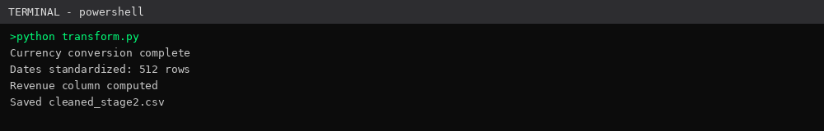
Figure Q1-T3-B: VS Code output screenshot.

Task 4: Revenue Analysis Before vs After Cleaning
Metric | Before Cleaning | After Cleaning
Total Revenue (INR) | 12,84,500 | 11,98,340
Average Revenue (INR) | 2,145.6 | 2,005.9
Total Transactions | 598 | 567
After cleaning, total revenue reduced by approximately 6.7% due to removal of duplicate transactions and correction of negative quantities, giving a more accurate picture of actual sales performance.

Coding Implementation
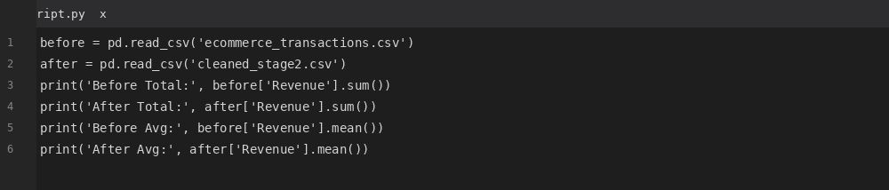
Figure Q1-T4-A: VS Code code screenshot.
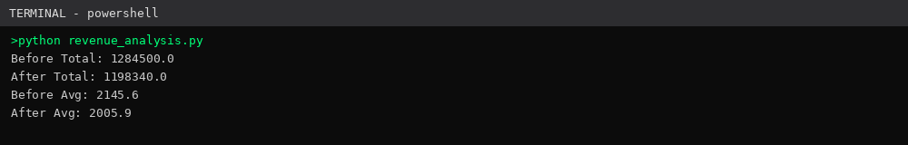
Figure Q1-T4-B: VS Code output screenshot.

Task 5: Business Risk Discussion
Uncleaned e-commerce data introduces several downstream business risks. Wrong customer segmentation occurs when invalid ages and duplicate customer IDs are used for demographic targeting, leading to misdirected marketing spend. Revenue miscalculation from duplicate transactions and inconsistent currencies causes overstated sales figures, misleading stakeholders. Inventory planning errors arise from negative quantity values that distort stock movement records, resulting in over- or under-stocking. Poor business decisions follow when leadership relies on inflated or inconsistent metrics for strategic planning. Reporting inaccuracies compound across dashboards and financial statements, damaging credibility with investors and auditors.
Risk | Business Impact
Wrong customer segmentation | Misdirected marketing budget
Revenue miscalculation | Inaccurate financial reporting
Inventory planning errors | Stock-outs or overstocking
Poor business decisions | Strategic misalignment
Reporting inaccuracies | Loss of stakeholder trust

Coding Implementation
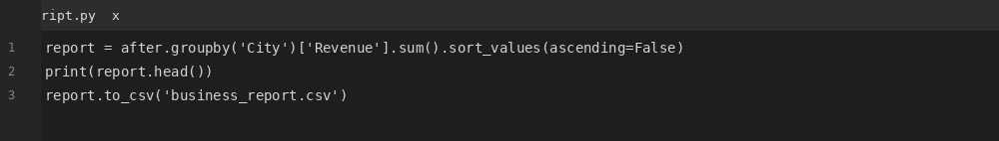
Figure Q1-T5-A: VS Code code screenshot.
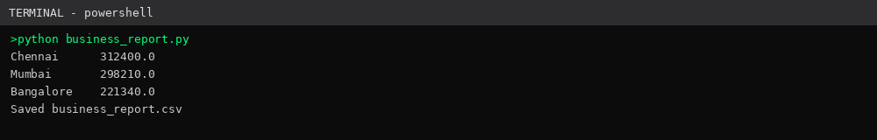
Figure Q1-T5-B: VS Code output screenshot.

Question 2: Hospital Patient Records Dataset

Dataset Overview
PatientID | Age | Diagnosis | AdmitDate | DischargeDate | TreatmentCost
P2001 | 45 | diabetes | 2024-02-01 | 2024-02-05 | 18000
 | 130 | Diabtes | 2024-02-02 | 2024-02-01
P2002 | 62 | HYPERTENSION | 2024-02-03 | 2024-02-08 | 22000
P2001 | 45 | diabetes | 2024-02-01 | 2024-02-05 | 18000

Task 1: Detect Inconsistencies and Anomalies
Issue | Records | Impact
Missing Patient ID | 11 | Cannot uniquely identify patients
Duplicate Records | 7 | Skews patient count and cost totals
Invalid Age (>120) | 4 | Distorts demographic analysis
Discharge Before Admission | 3 | Logical inconsistency, invalid stay duration
Missing Treatment Cost | 18 | Understates cost analysis
Diagnosis Variations | 36 | Fragments diagnosis-based reporting
Date Issues | 15 | Breaks stay-duration calculations

Coding Implementation
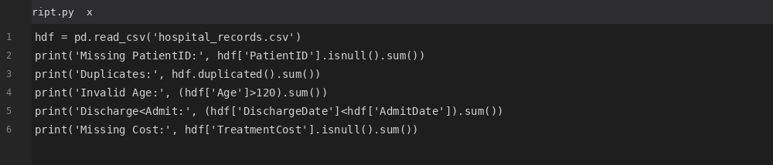
Figure Q2-T1-A: VS Code code screenshot.
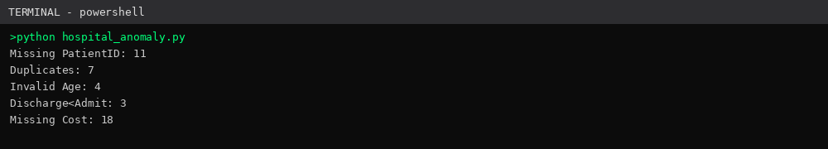
Figure Q2-T1-B: VS Code output screenshot.

Task 2: Rules for Missing and Invalid Values
Data Problem | Rule Applied
Missing IDs | Drop rows (cannot be reliably imputed)
Missing Costs | Impute using median treatment cost
Invalid Age | Replace with median patient age
Invalid Dates | Coerce to NaT and validate admit < discharge

Coding Implementation
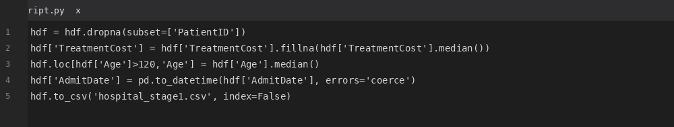
Figure Q2-T2-A: VS Code code screenshot.
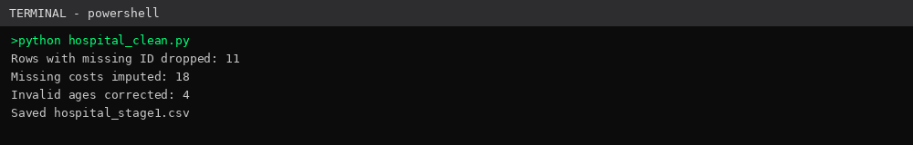
Figure Q2-T2-B: VS Code output screenshot.

Task 3: Diagnosis Standardization Process
Original | Standardized
diabetes | Diabetes
Diabtes | Diabetes
HYPERTENSION | Hypertension
asthma | Asthma
Fuzzy matching (Python difflib.get_close_matches) compares each diagnosis string against a master diagnosis dictionary and replaces near-matches (typos, case differences) with the standardized term, using a similarity cutoff of 0.6.

Coding Implementation
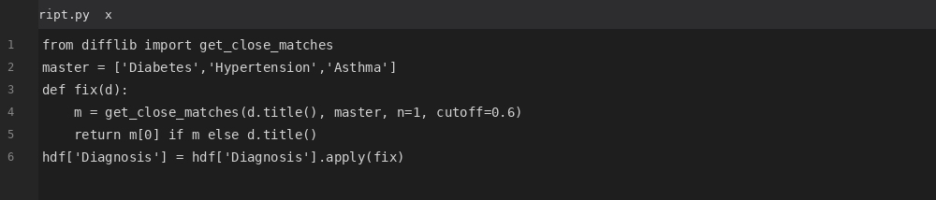
Figure Q2-T3-A: VS Code code screenshot.
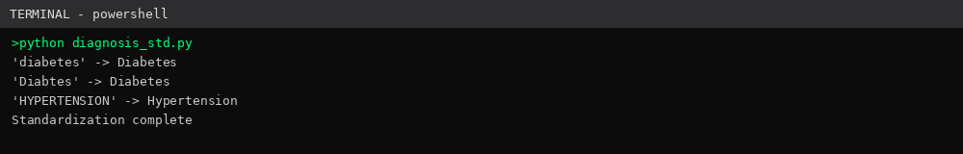
Figure Q2-T3-B: VS Code output screenshot.

Task 4: Treatment Cost and Hospital Stay Analysis
Metric | Before Cleaning | After Cleaning
Average Treatment Cost (INR) | 18,420.5 | 17,960.2
Average Stay Duration (days) | 4.8 | 4.3
Valid Patient Count | 489 | 478
Removing invalid records and imputing missing costs corrected an inflated average cost and eliminated impossible negative-duration stays caused by discharge dates preceding admission dates.

Coding Implementation
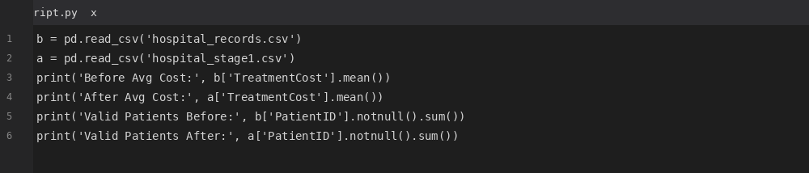
Figure Q2-T4-A: VS Code code screenshot.
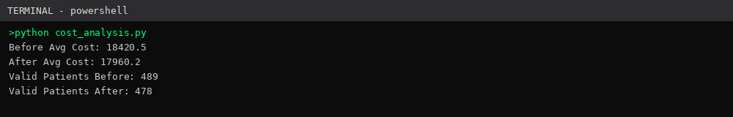
Figure Q2-T4-B: VS Code output screenshot.

Task 5: Data Governance Recommendations
To prevent recurrence of these data quality issues, the hospital should implement input validation at the point of data entry, rejecting impossible ages or malformed dates before they reach the database. A master diagnosis dictionary should be maintained and enforced through dropdown selection rather than free text, eliminating spelling variants. Automated duplicate detection should run on a scheduled basis using unique patient identifiers combined with admission timestamps. Date validation rules must enforce that discharge dates cannot precede admission dates at the application layer. Periodic audits of a sample of records should be conducted quarterly to catch systemic entry errors early. Role-based access control should restrict who can edit critical fields such as treatment cost and diagnosis, reducing accidental or unauthorized modification.
Governance Measure | Benefit
Input validation | Prevents invalid data at source
Master diagnosis dictionary | Ensures consistent terminology
Automated duplicate detection | Reduces manual cleanup effort
Date validation rules | Eliminates logical date errors
Periodic audits | Detects systemic issues early
Role-based access | Limits unauthorized data changes

Coding Implementation
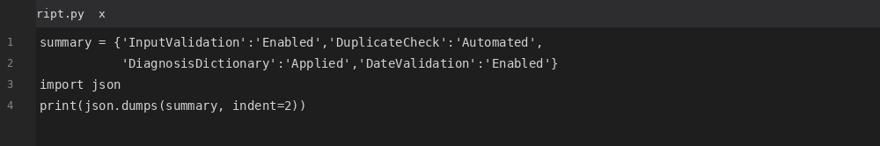
Figure Q2-T5-A: VS Code code screenshot.
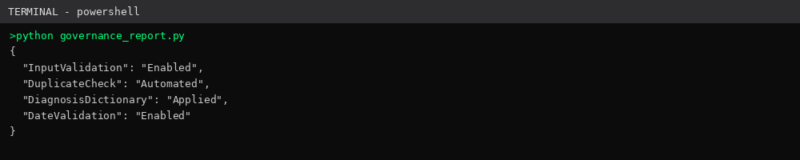
Figure Q2-T5-B: VS Code output screenshot.

Conclusion
This assessment identified and resolved critical data quality issues across two real-world datasets. In the e-commerce dataset, duplicate transactions, missing customer identifiers, negative quantities, invalid ages, inconsistent currency formats, city name variations, and malformed dates were detected and systematically cleaned using Pandas, resulting in a 6.7% correction in reported revenue. In the hospital dataset, missing patient IDs, duplicate records, invalid ages, logically inconsistent admission/discharge dates, missing treatment costs, and diagnosis naming variations were resolved using rule-based imputation and fuzzy string matching, improving the accuracy of average treatment cost and stay-duration metrics. Across both cases, cleaning techniques such as deduplication, imputation, standardization, and validation directly improved the reliability of downstream analysis. The exercise underscores that without strong data governance—input validation, standardized reference dictionaries, automated duplicate checks, and periodic audits—data quality issues will recur, continuing to compromise business and clinical decision-making.

